TELCO CUSTOMER CHURN

PREDICTION MODEL

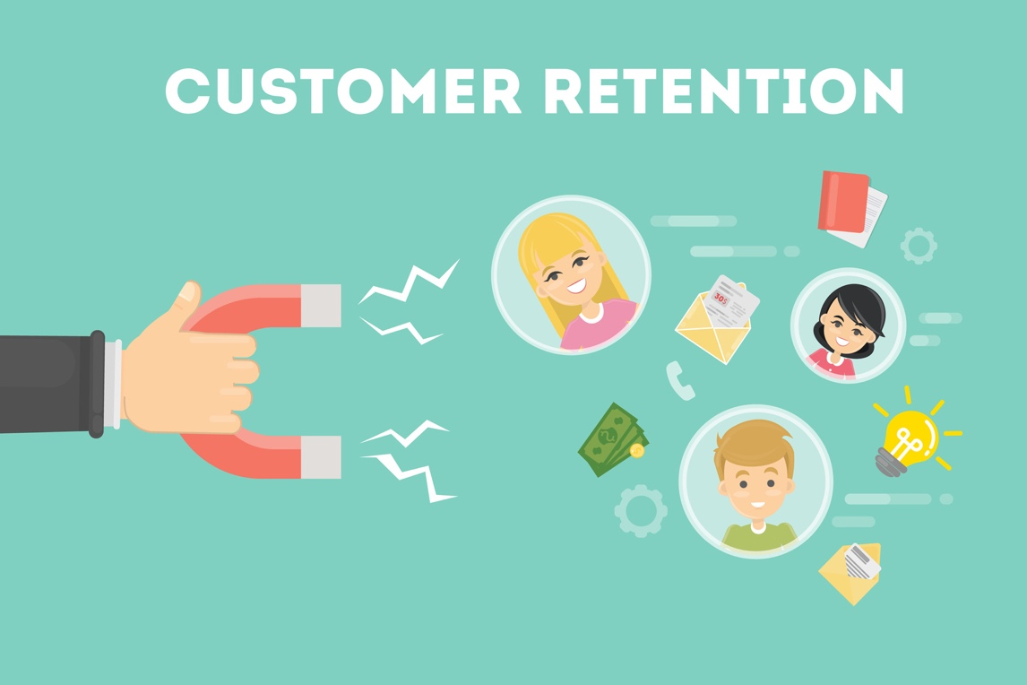

ISM6136.901F21 DATA MINING

Team Members:

Shraddha Shinde

Onkar Salunke

Sivaramakrishna Allam

Manisha Nagarapu

TELCO CUSTOMER CHURN PREDICTION MODEL

**Abstract:**

Customer churn rate, also known as attrition rate, is the rate at which an organization’s customer base stops doing business with the company. It is usually that chunk of user base, who terminate their service contracts with the company before a stipulated time frame. For an organization to earn profit, their overall growth rate must be higher than their churn rate. In the telecommunications business, the churn rate is an extremely useful metric. It includes operators of satellite or cable television, Internet service providers, and phone services.

Because most consumers have a multitude of choices to choose from, the churn rate can assist a business to analyze how it compares to its counterparts in the marketplace. However, the most effective strategy to avoid customer churn is for a business to fully understand its customers. Companies may anticipate consumers' demands and concerns by using Big Data and a customer analytics to gain insights into them. This allows them to fulfill their expectations and keep their business safe and robust. This entails identifying clients who are likely to leave and striving to enhance their satisfaction. Churn analytics serves as a useful tool for predicting customer churn and identifying the root causes. The number of consumers who discontinue a product or service during a specific period is commonly referred to as churn.

In our project, we're attempting to use predictive models to forecast attrition on a per-customer basis and implement means to mitigate such as offering better discounts, special offers, or other gratifications to retain consumers. A common classification task in the domain of supervised learning is a customer churn analysis.

**Problem Definition:**

Customer churn is a serious and tricky problem that businesses and industries face. The major driver is a business's urgent desire to keep existing clients, along with the significant expense of gaining new clients.

Our prime focus would be to highlight the underlying factors that may be contributing to possible customer churn in the organization. Our target variable would be ‘customer churn’, which would determine whether the specific customer will churn or not. For this purpose, we’ll be employing multiple predictive models and comparing how well they fare against each other. The models will be trained using 75% of the input data, and subsequently the remaining 25% data would be used to assess the trained models and make the predictive analysis. The precision of the models is evaluated to compare them and then choose the best for our objective

**Dataset Details:**

For performing this project, our team has made use of a dataset named – “**Telco Customer Churn**”, from Kaggle. On further inspecting the dataset, we can explain the constituent attributes/parameters as follows:

1. **Customer ID:** It’s the unique identification sequence used to represent individual entries in the dataset.
2. **Gender:** This column specifies the gender of the customer in that row (Whether they are male or female).
3. **SeniorCitizen:** Specifieswhether the customer is a senior citizen or not.
4. **Dependents:** Specifies whether that customer has any dependents or not.
5. **Tenure:** It specifies the total duration for which the customer used the company’s service.
6. **PhoneService:** Specifies whether the customer has subscribed to the company’s phone service or not.
7. **MultipleLines:** This specifies whether the customer has subscribed to multiple lines from the provider.
8. **InternetService**: Specifies whether the user has subscribed to the provider’s internet services.
9. **OnlineSecurity**: Specifies whether the user has subscribed to the provider’s online security feature.
10. **OnlineBackup:** This specifies whether the user has access to the Online Backup feature.
11. **DeviceProtection:** Specifies whether the user has device protection.
12. **TechSupport:** Specifies whether the user utilizes the tech support functionality.
13. **StreamingTV:** Specifies whether the customer has subscribed to the provider’s TV Streaming services.
14. **StreamingMovies:** Specifies whether the customer has subscribed to the provider’s Movie Streaming services.
15. **Contract:** Mentions the contract term for that customer.
16. **PaperlessBilling:** Mentions whether the customer has opted for Paperless Billing or not.
17. **PaymentMethod:** It will specify the type of billing/payment method employed by the user/customer to make their service-related payments.
18. **MonthlyCharges:** Specifies the monthly charges that were charged to the user.
19. **TotalCharges:** Specifies the total charges till date, that have been charged to the user.
20. **Churn:** Specifieswhether the user will churn or not. This will be our **TARGET/DEPENDENT VARIABLE**.

**Dataset Snippet:**

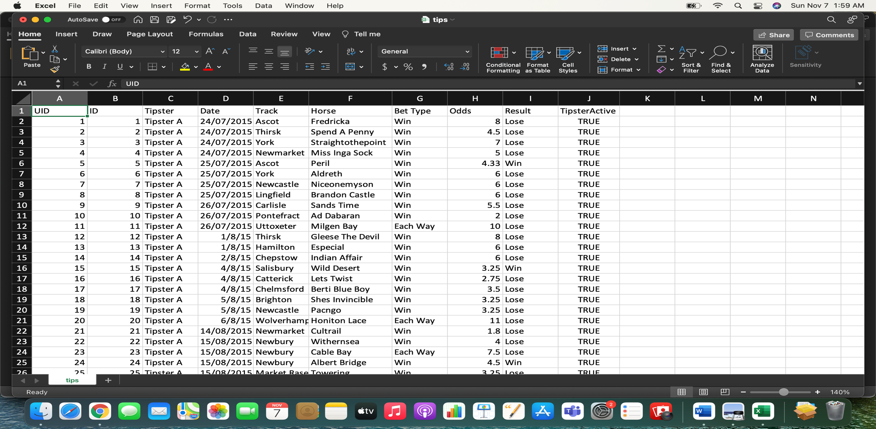

**Various Metrics to compare our models:**

1. **Confusion Matrix:** It displays the quantity of the positive and negative classes from the actual positives and negatives**.**

True Positives: These are the instances where we made a positive prediction, and it turns out to be true.

True Negatives: These are instances where we made a negative prediction, and it turns out to be true.

False Positives: These are the instances where we made a positive prediction, and it turns out to be false.

False Negatives: These are the instances where we made a negative prediction, and it turns out to be false.

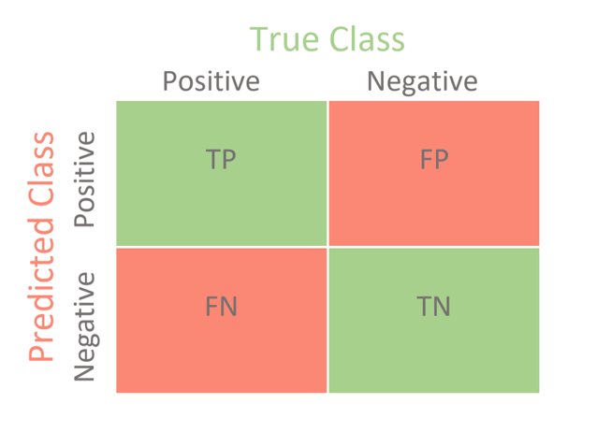

1. **Accuracy Score:** Accuracy score indicates the extent of accuracy for the selected model after employing the training and test data sets.
2. **Area Under Curve (AUC):** The Area Under the Curve (AUC) is a summary of the ROC curve that measures a classifier's capacity to differentiate among classes. The AUC indicates how well the model distinguishes between positive and negative classes. The greater the AUC, the better it is.
3. **ROC Curve:** The trade-off between the true positive rate and the false positive rate for a predictive model utilizing distinctive probability thresholds is summarized by ROC Curves.
4. **F1 Score:** The weighted average of Precision and Recall is the F1 Score. As a result, this score considers both false positives and false negatives. It builds harmonic mean of precision & recall and hence calculates the compromise between them.

**Predictive Model:**

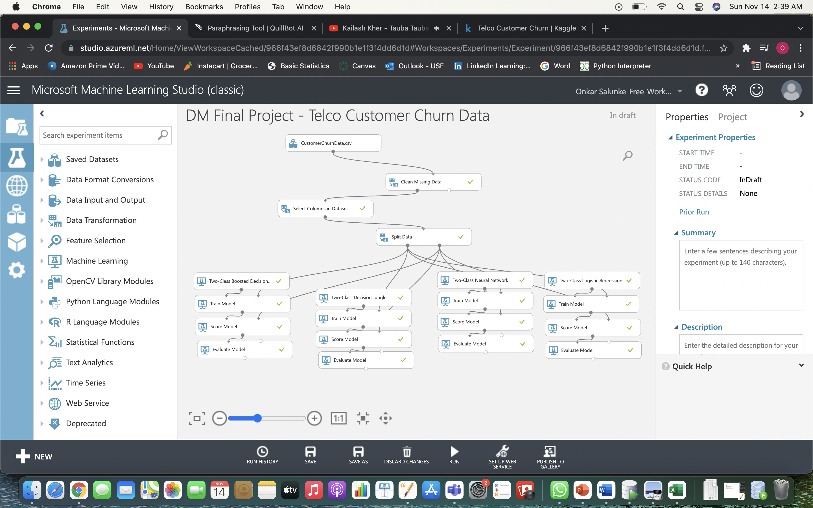

In this predictive model, we have employed 4 algorithms/models and compared how well they fared. The input dataset was initially imported, and its significant columns were selected for further modelling purpose. Next, the data is split into training and test data. We split 75% of the data for training purpose and remaining 25% for testing purpose.

Further the following models are used for our purpose:

1. **Two-class Boosted Decision:** In this sort of model, the consequent decision trees correct the errors of the previous tree. This way, they get cancelled and the accuracy improves with each step. This is an ensemble machine learning method.
2. **Two-class Decision Jungle:** To develop a machine learning model based on the random choice forests algorithm, use the Two-Class Decision Forest module. Decision forests have supervised ensemble models that run quickly. This module can be used to anticipate a two-valued target.
3. **Two-class Neural Network:** Even though the data set is minimal and that neural networks typically require a large amount of training data to have useful predictive ability, a rudimentary neural network is used to compare the two approaches.
4. **Two-class Logistic Regression:** Logistic regression is a well-known statistical method for predicting the probability of a given result, and it is particularly useful for classification problems. By fitting the data to a logistic function, the method estimates the likelihood of an event occurring.

**Model Outcomes:**

1. **Two-class Boosted Decision:**

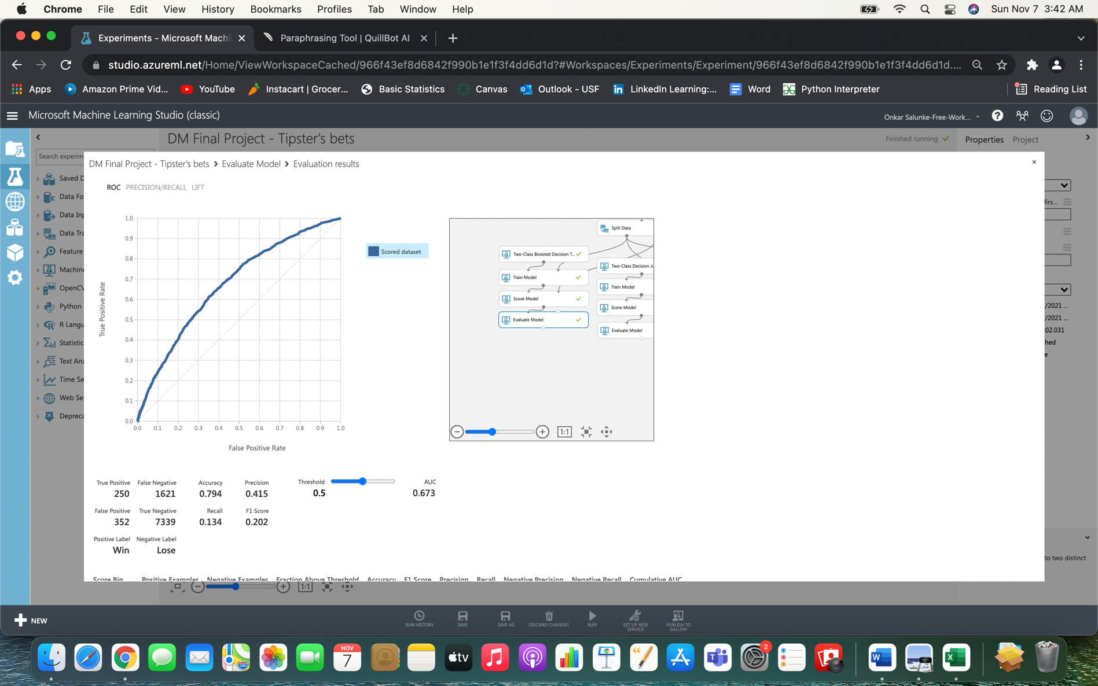 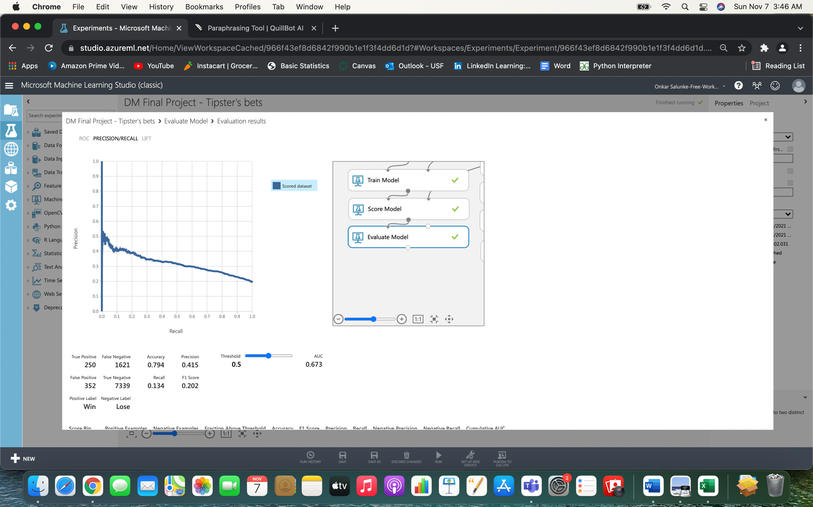

**ROC Curve Precision/Recall Curve**

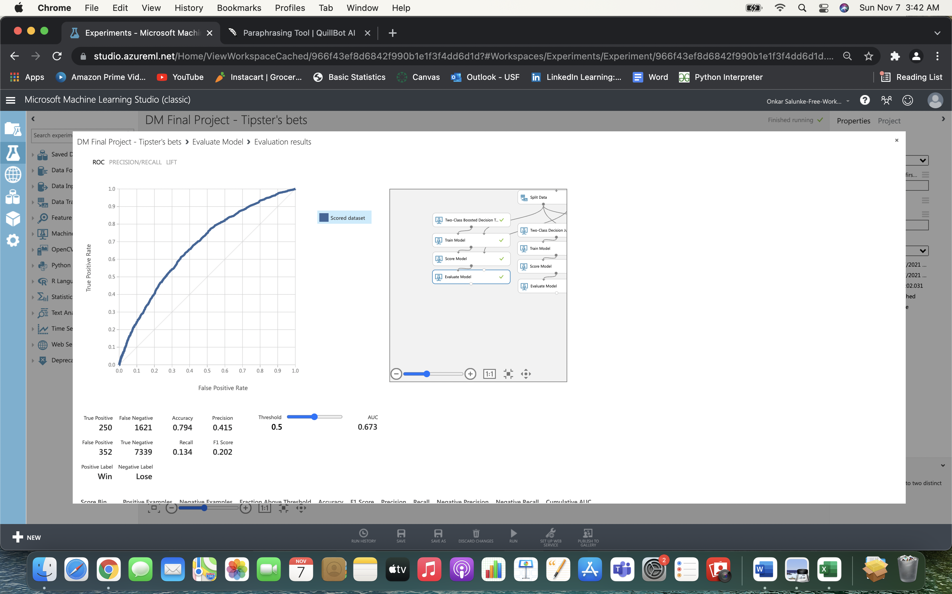

**2)Two-class decision jungle:**

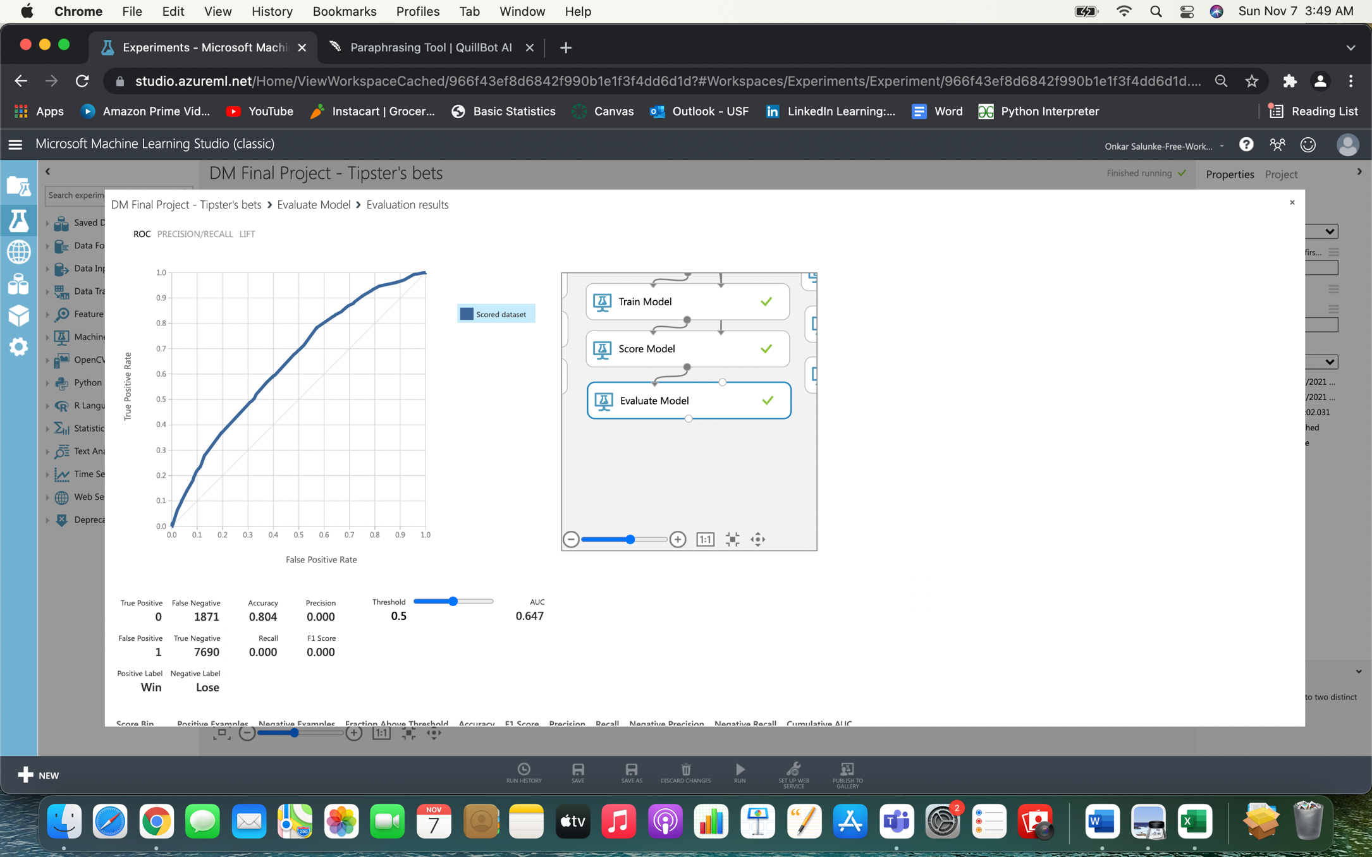 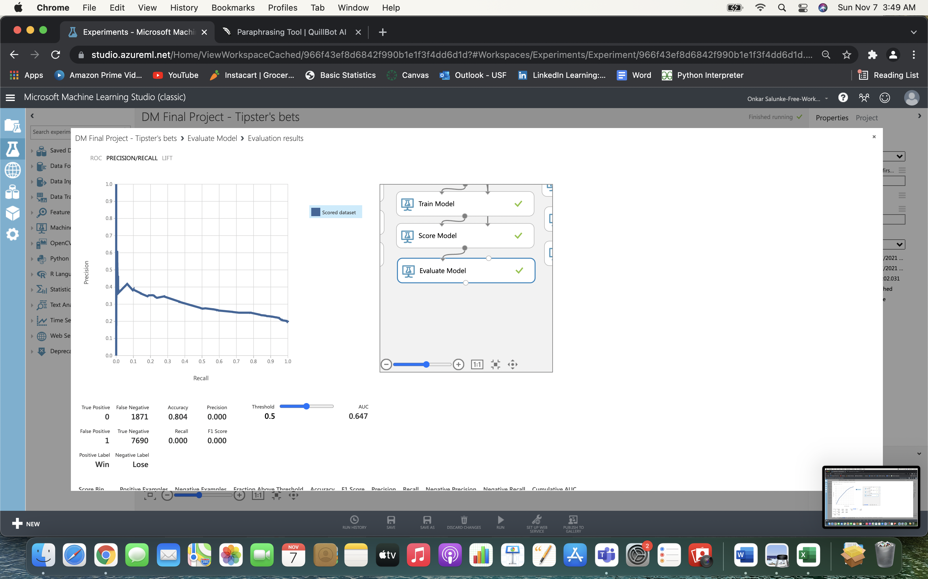

**ROC Curve Precision/Recall Curve**

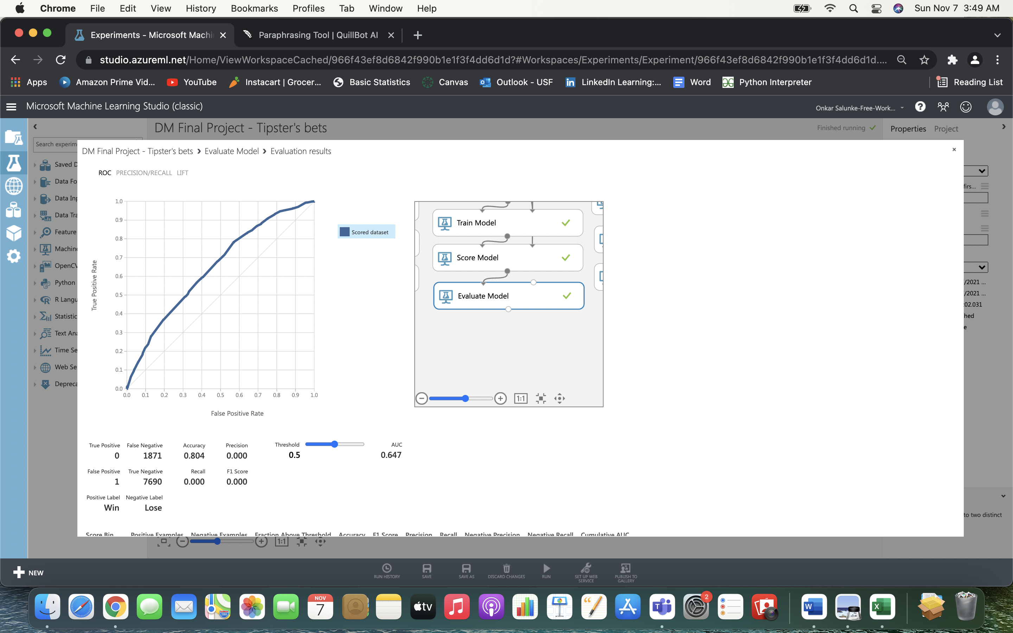

**3)Two-class Neural Network:**

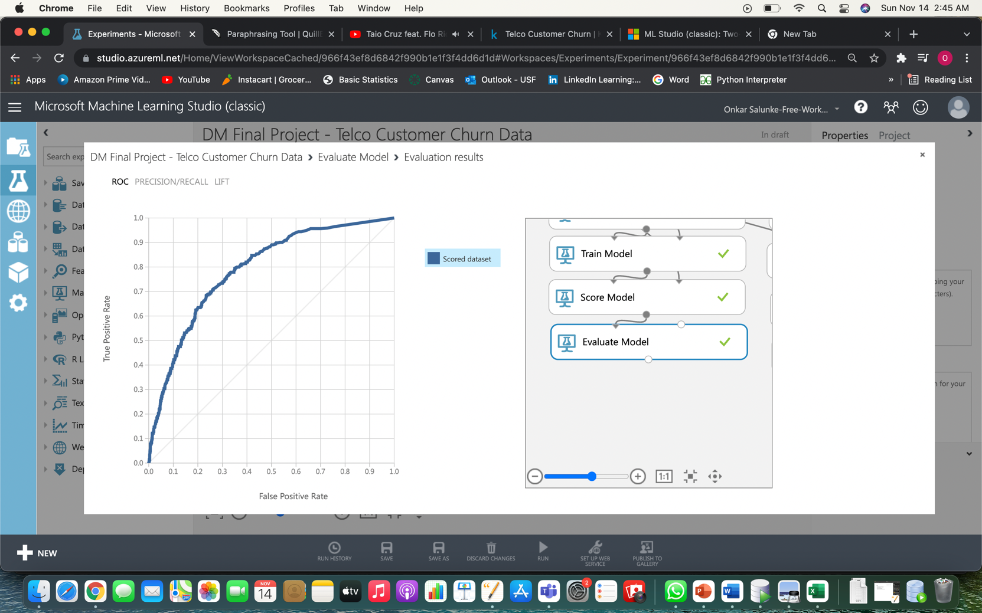 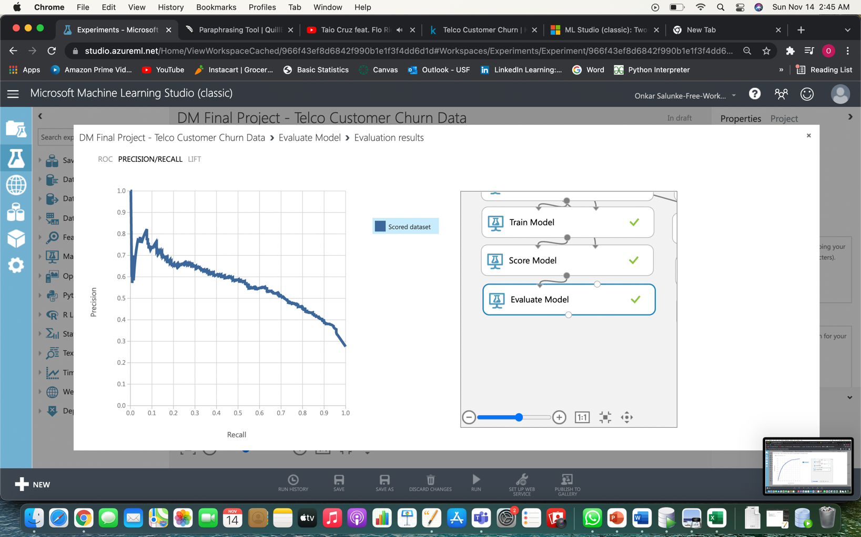

**ROC Curve Precision/Recall Curve**

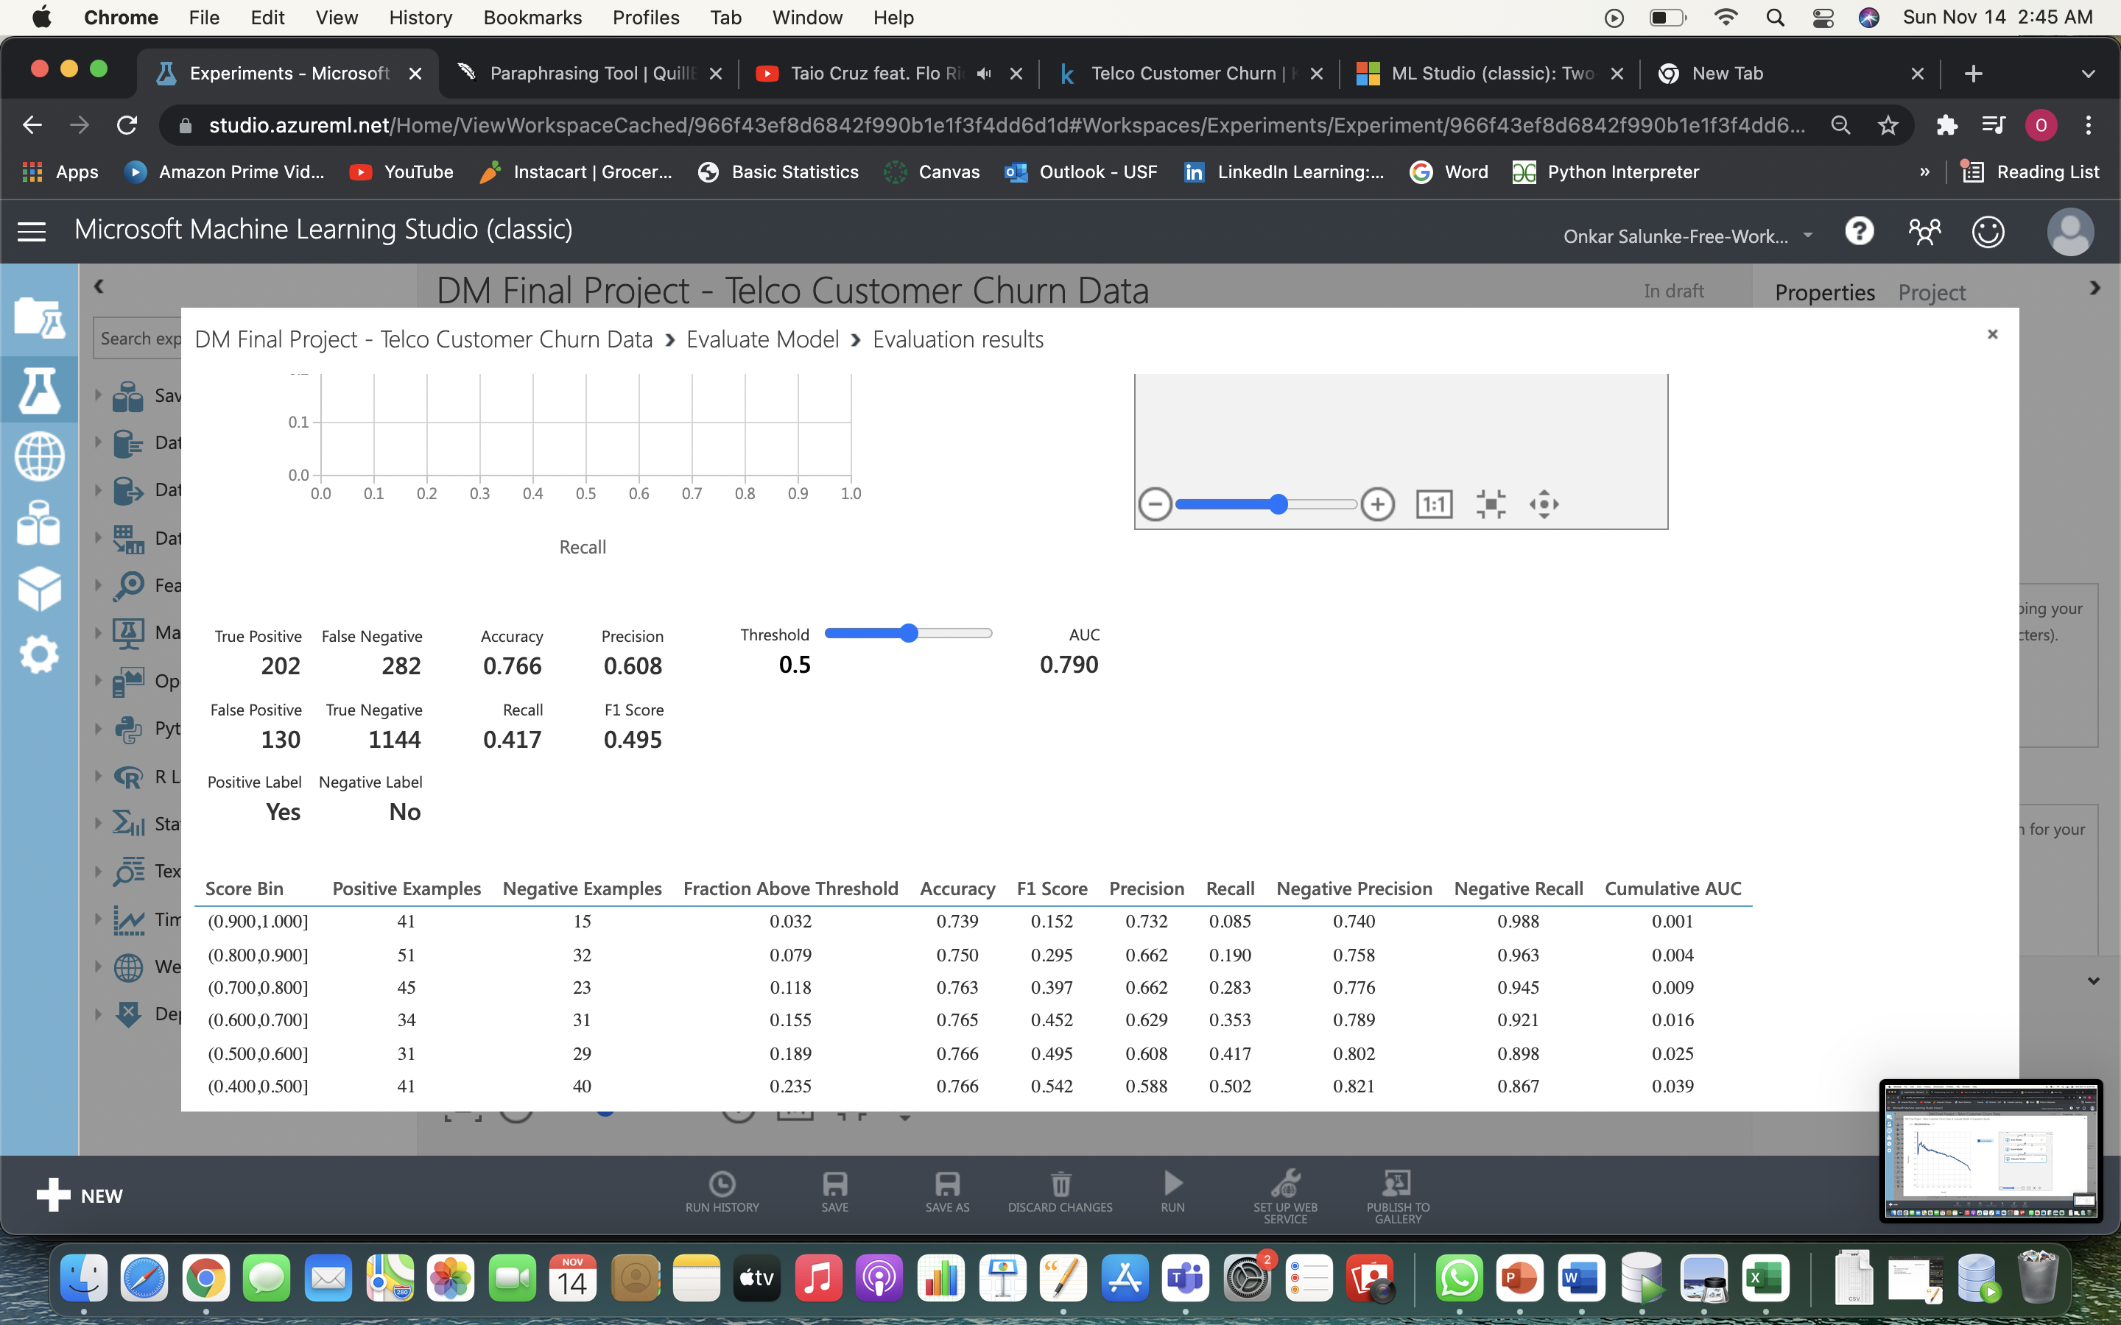

1. **Two-class Logistic Regression:**

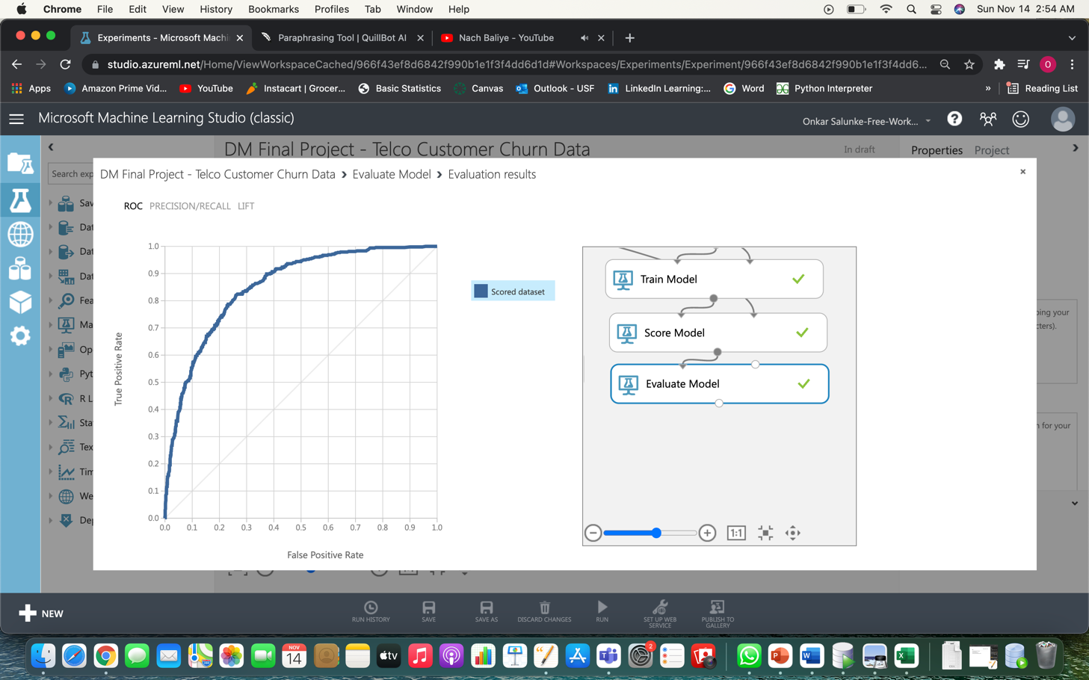 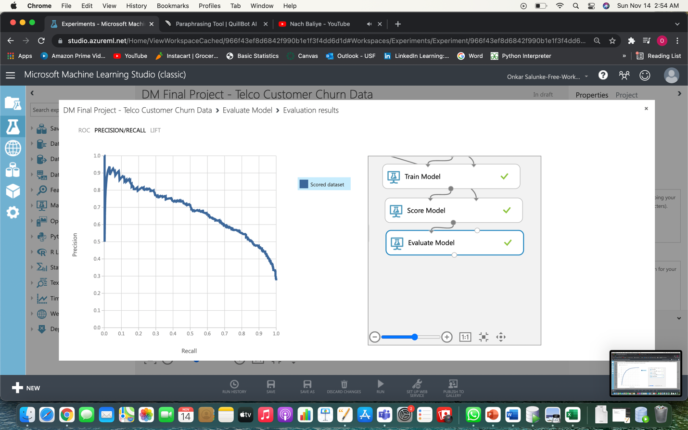

**ROC Curve Precision/Recall Curve**

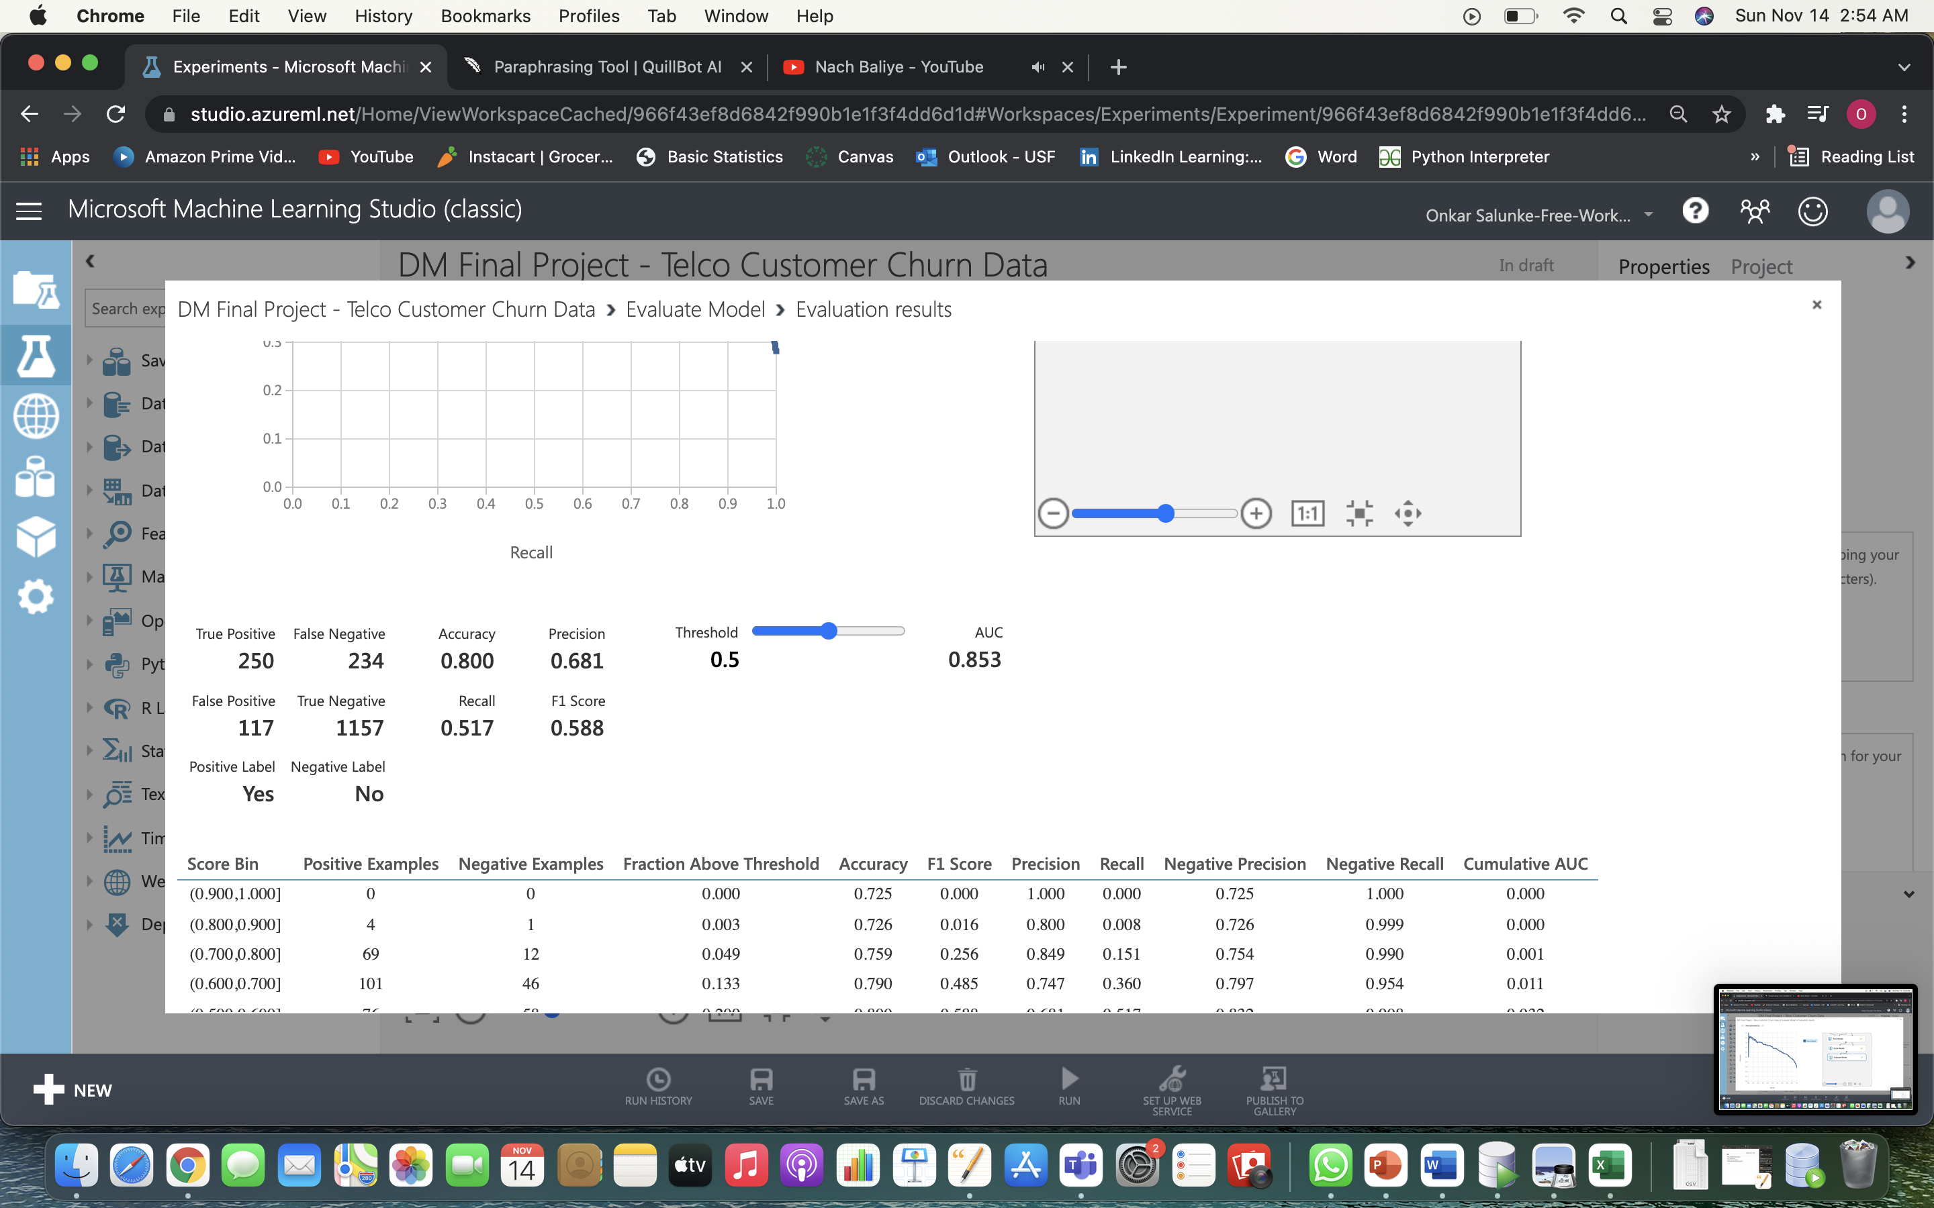

**Model Performance Comparison Table:**

|  |  |  |  |  |  |  |  |  |  |  |
| --- | --- | --- | --- | --- | --- | --- | --- | --- | --- | --- |
| **Model** | **True Positive** | **True Negative** | **False Positive** | **False Negative** | **Accuracy** | **Precision** | **Recall** | **F1 Score** | **AUC** | **Threshold** |
| **Two-class Boosted Decision** | 271 | 1108 | 166 | 213 | 0.784 | 0.62 | 0.56 | 0.588 | 0.838 | 0.5 |
| **Two-class Decision Jungle** | 230 | 1167 | 107 | 254 | 0.795 | 0.682 | 0.475 | 0.56 | 0.85 | 0.5 |
| **Two-class Neural Network** | 202 | 1144 | 130 | 282 | 0.766 | 0.608 | 0.417 | 0.495 | 0.79 | 0.5 |
| **Two-class logistic Regression** | 250 | 1157 | 117 | 234 | 0.8 | 0.681 | 0.517 | 0.588 | 0.853 | 0.5 |

**Conclusion:**

Based on the model findings, the Two-class logistic regression model with an accuracy of 0.80 after optimization has the highest accuracy on the testing dataset.

For subscription-based businesses, the churn rate is a key metric. The capacity to identify consumers who are dissatisfied with offered solutions allows organizations to gain insight about product or price plan flaws, operational challenges, as well as client preferences, in order to prevent churn.

Our Machine Learning model may be appropriately trained to obtain higher accuracies if we used them. To be able to identify prospective client scenarios where churn can be avoided and consumers satisfied, a high level of accuracy is required.